The Battle of Lexington and Concord (April 19, 1775)
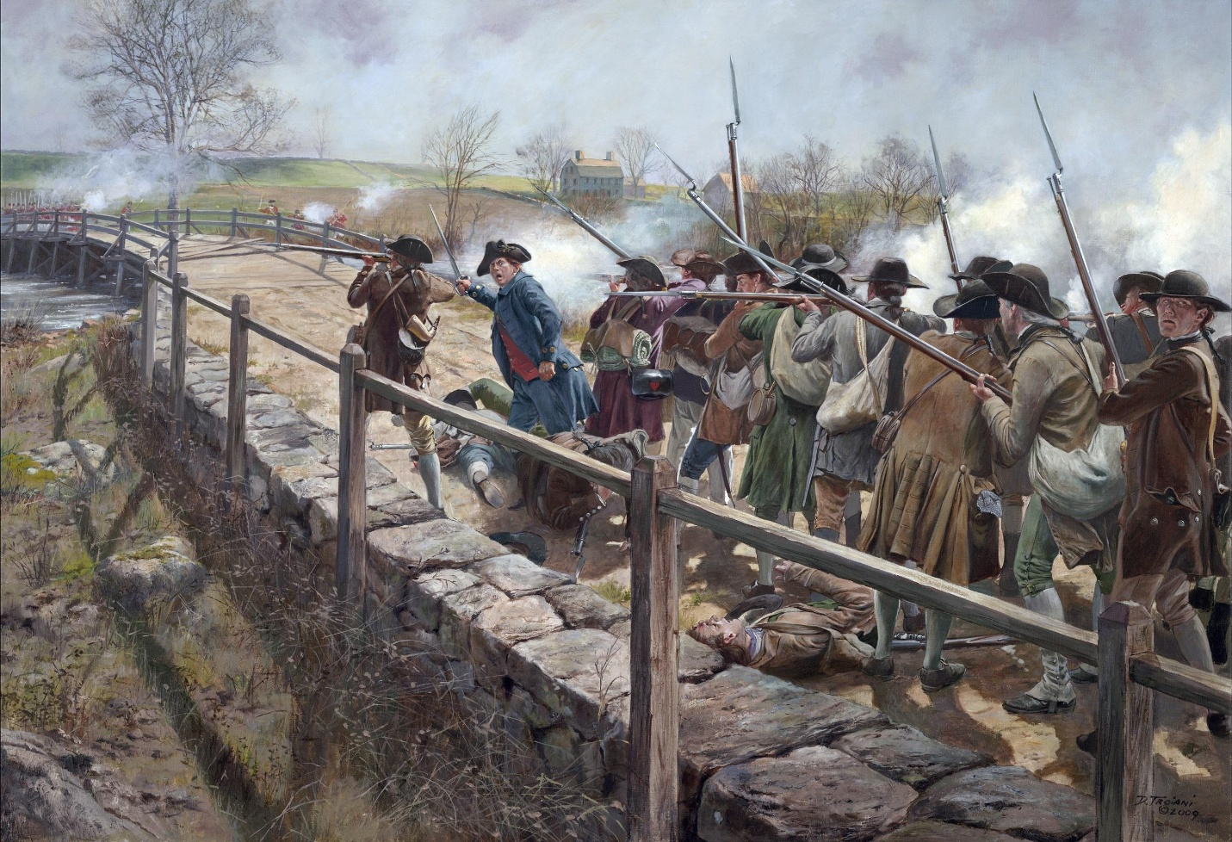

The Battle of Lexington and Concord was the first official military conflict of the American Revolution. It marked the moment when tensions between the American colonists and Great Britain turned into open war.
What led to the battle?
The British government wanted to keep control over the colonies and had been taxing them without giving them representation in government. Many colonists were angry. They began storing weapons and forming local militias (citizen soldiers).
British leaders decided to send troops to Concord, Massachusetts to seize these weapons and arrest colonial leaders like Samuel Adams and John Hancock.
Before the fighting began, a series of important events warned the colonists that the British were coming.
The British plan
British General Thomas Gage secretly ordered troops to march from Boston to Concord to seize weapons and arrest Patriot leaders like Samuel Adams and John Hancock.
The signal in the church
Patriots in Boston had a plan to warn others.
At Old North Church, lanterns were hung in the steeple:
- One lantern = the British were coming by land
- Two lanterns = the British were coming by sea
That night, two lanterns were lit—meaning the British were crossing the water to begin their march.
The midnight riders
Several riders spread the warning across the countryside:
- Paul Revere
- William Dawes
- Samuel Prescott
As they rode through towns, they warned:
“The British are coming!”
Because of these riders, local militias were ready before the British arrived.
What happened at Lexington?
Early in the morning of April 19, 1775, about 700 British soldiers arrived in Lexington. Around 70 colonial militiamen were waiting on the town green.
No one knows who fired the first shot—this is often called “the shot heard ’round the world.”
- The British soldiers fired and quickly defeated the small militia.
- Several colonists were killed, and the British moved on toward Concord.
What happened at Concord?
When the British reached Concord, they searched for weapons but found and destroyed only a few supplies.
Meanwhile, more colonial militia gathered. At the North Bridge in Concord:
- The colonists fought back and forced the British to retreat.
- This was the first time colonial forces successfully pushed back British troops.
What happened during the retreat?
As the British soldiers marched back to Boston:
- Thousands of colonial militiamen attacked them from behind trees, fences, and buildings.
- The British suffered heavy losses during this long retreat.
Why was it important?
- It was the first battle of the American Revolution.
- It showed that colonial militias could stand up to the British army.
- It united many colonists in the fight for independence.
Summary:
The Battle of Lexington and Concord began as a British mission to seize weapons—but it turned into the start of a war that would lead to American independence.

